Chapter 2
REVIEW OF RELATED LITERATURE
Chapter 2 presents the body of knowledge that supports your study. It positions your research within the academic and practical conversations that have already taken place, highlighting what has been done, what is known, and what gaps remain. This chapter not only justifies your study’s direction but also establishes your credibility as a researcher grounded in relevant literature and systems.
Begin with the Review of Related Literature, which should be organized according to your specific objectives. For each objective listed in Chapter 1, provide a focused discussion of studies, models, or existing systems that relate to that objective. This approach creates a direct connection between your goals and the literature, helping readers understand the theoretical or practical basis behind each part of your study. When writing each section, summarize key findings from previous works, highlight the methodologies used, and note any strengths or weaknesses relevant to your project. Make sure to properly cite all sources using the required referencing style. For system reviews, describe how current systems work, their features, and how they address problems similar to those in your own
study. Emphasize points of comparison and relevance.
Requirement Analysis
According to Tsang, S. (2018), blah blbal blahhhhhhhhhh hadjshdjsd skfjdkfjdsdlsdksl fkgjlf kfgflgklf
Figure 1 shows label name of the figure.
Figure 1
Label or name of the figure

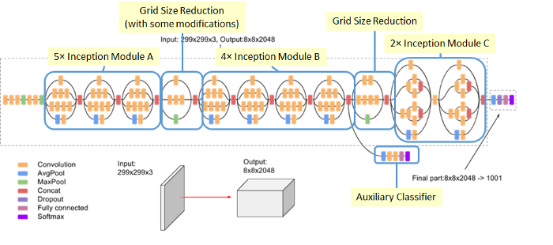
With this architecture, it is said to have 42 layers deep. Moreover, he has derived the architecture of Inception-v3 as shown in figure 1 having labelled at the top from left as 5x Inception Module A, Grid size reductions with modifications, 4x Inception Module B, Grid size Reduction, and 2x Inception Module C while at the Grid size Reduction.
System Design
Lorem ipsum dolor sit amet, consectetur adipiscing elit, sed do eiusmod tempor incididunt ut labore et dolore magna aliqua. Ut enim ad minim veniam, quis nostrud exercitation ullamco laboris nisi ut aliquip ex ea commodo consequat. Duis aute irure dolor in reprehenderit in voluptate velit esse cillum dolore eu fugiat nulla pariatur. Excepteur sint occaecat cupidatat non proident, sunt in culpa qui officia deserunt mollit anim id est laborum.set of task (Russakovsky et. al., 2015).
SObj 3 in shortened phrase form
According to Szegedy, c et al., cross entropy a loss function having the formula:
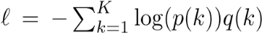
Where the tag is selected according to its ground-truth distribution q(k). They goes on to say that gradient has a rather simple form:
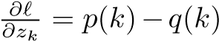,
which is bounded between −1 and 1.
Lorem ipsum dolor sit amet, consectetur adipiscing elit, sed do eiusmod tempor incididunt ut labore et dolore magna aliqua. Ut enim ad minim veniam, quis nostrud xercitation ullamco laboris nisi ut aliquip ex ea commodo
Consequat sed do eiusmod tempor incididunt ut labore.
Synthesis of the State-of-the-Art
Develop the Synthesis of the State-of-the-Art, which
summarizes and compares the key ideas, frameworks, or technologies from the reviewed literature. This section should not be a list of summaries, but rather an integrated narrative that demonstrates how the literature collectively informs the current state of knowledge or practice. Identify trends, common themes, recurring limitations, or conflicting findings. A well-crafted synthesis shows how various works relate to one another and to your project. It should lead logically to the identification of a need for your study.
Gap Bridged by the Study
Conclude with the Gap Bridged by the Study, a crucial part of the chapter that clearly articulates what has not been addressed in previous research or systems and how your project intends to fill that void. This section should draw directly from your synthesis to highlight what is missing or insufficient in the existing body of work. Whether the gap is theoretical, practical, methodological, or technological, state it explicitly. Then, explain how your project offers a novel contribution or improvement. This helps establish your study’s significance and relevance, connecting the literature review back to your research objectives and overall purpose.

